--Source Code--

/*
Programmer : Catalina Lamboglia
Course : CS211D
Assignment : #1
This program displays four text views, each in their
own color
*/
package com.example.hw1;
import android.app.Activity;
import android.os.Bundle;
import android.view.Window;
public class MainActivity extends Activity {
@Override
protected void onCreate(Bundle savedInstanceState) {
super.onCreate(savedInstanceState);
requestWindowFeature(Window.FEATURE_NO_TITLE);
setContentView(R.layout.activity_main);
}
}

–- main.xml –-

<?xml version="1.0" encoding="utf-8"?>
<LinearLayout xmlns:android="http://schemas.android.com/apk/res/android"
xmlns:app="http://schemas.android.com/apk/res-auto"
xmlns:tools="http://schemas.android.com/tools"
android:layout_width="fill_parent"
android:layout_height="fill_parent"
android:orientation="vertical"
tools:context=".MainActivity"
android:background="@color/darkBlue">
<TextView
android:id ="@+id/firstLine"
android:layout_width="fill_parent"
android:layout_height="wrap_content"
android:text="@string/courseTitle"
android:textColor="@color/skyBlue"
android:gravity="center"
/>
<TextView
android:id="@+id/secondLine"
android:layout_width="fill_parent"
android:layout_height="wrap_content"
android:text="@string/semester"
android:textColor="@color/neonTeal"
android:gravity="center"
/>
<TextView
android:id="@+id/thirdLine"
android:layout_width="match_parent"
android:layout_height="wrap_content"
android:text="@string/myName"
android:textColor="@color/kiwi"
android:gravity="center"
/>
<TextView
android:id="@+id/fourthLine"
android:layout_width="match_parent"
android:layout_height="wrap_content"
android:text="@string/assignment"
android:textColor="@color/dirt"
android:gravity="center"
/>
</LinearLayout>

--strings.xml--

<resources>
<string name="app_name">HW#1</string> <!--Auto gen-->
<string name="courseTitle">CS211D</string> <!--First Line-->
<string name="semester">Spring 2019</string> <!-- 2nd -->
<string name="myName">Catalina Lamboglia</string> <!-- 3rd -->
<string name="assignment">HW #1</string> <!-- 4th -->
</resources>

–- color.xml--

<?xml version="1.0" encoding="utf-8"?>
<resources>
<color name="colorPrimary">#008577</color> <!--Auto gen-->
<color name="colorPrimaryDark">#00574B</color> <!--Auto gen-->
<color name="colorAccent">#D81B60</color> <!--Auto gen-->
<color name="kiwi">#61CA2A</color>
<color name="darkPurple">#900C3F</color>
<color name="blue">#1792ED</color>
<color name="skyBlue">#86C3F0</color>
<color name="red">#F1120C</color>
<color name="neonTeal">#0CF18C</color>
<color name="dirt">#D8A277</color>
<color name="crimson">#991D05</color>
<color name="darkBlue">#073E63</color>
</resources>

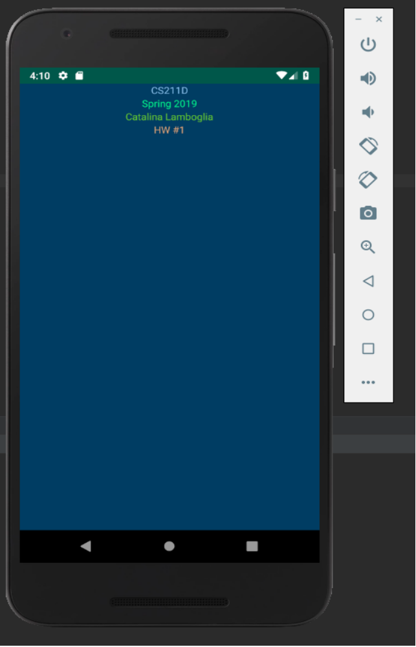
–- Sample Output --

